**IDEATION PHASE**

**Define the Problem statements**

| Date | 24-09-2022 |
| --- | --- |
| Team ID | PNT2022TMID26105 |
| Project Name | Real time river water quality monitoring and control system |
| Maximum marks | 2 marks |

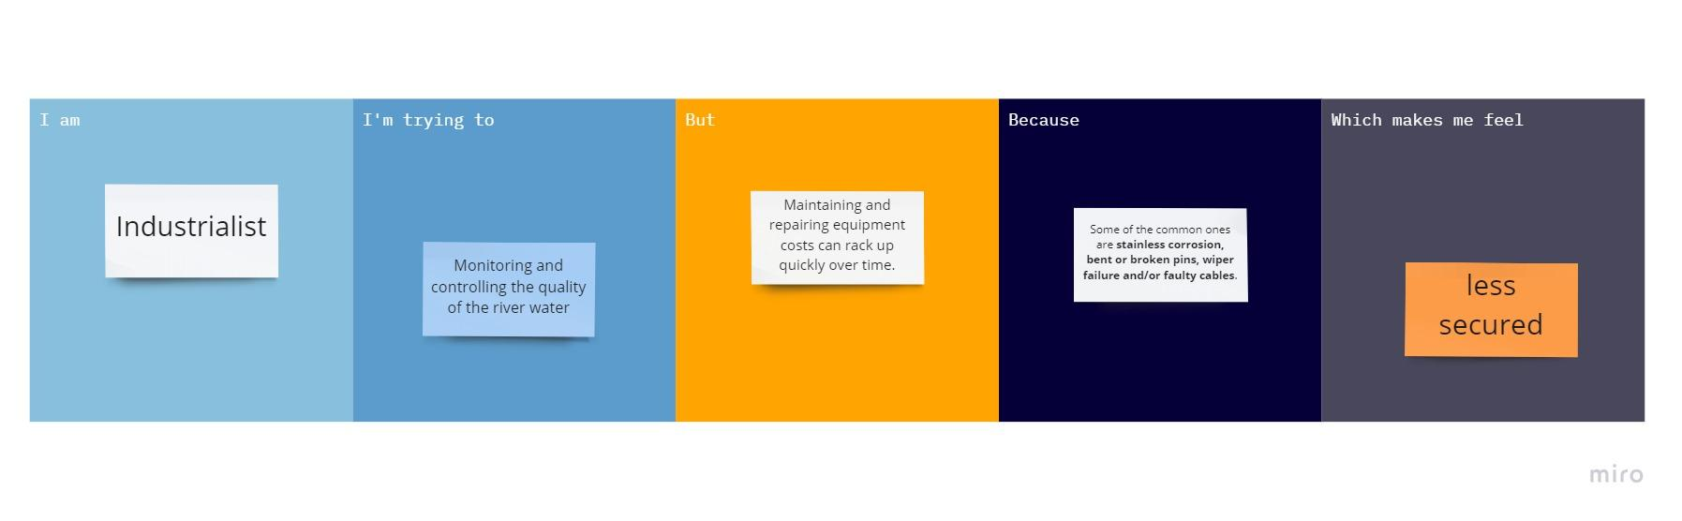

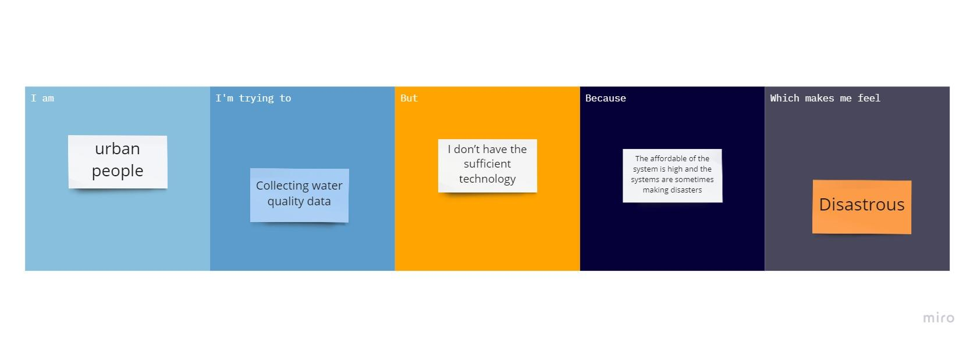

| **Problem Statement (PS)** | **I am (Customer)** | **I am trying to** | **But** | **Because** | **Which makes me feel** |
| --- | --- | --- | --- | --- | --- |
| **PS-1** | **Industrialist** | **Monitoring and controlling the quality of the river water** | **Maintaining and repairing equipment costs can rack up quickly over time** | **Some of the common ones are stainless corrosion, bent or broken pins, wiper failure and/or faulty cables** | **Less secured** |
| **PS-2** | **Urban people** | **Collecting water quality data** | **I don’t have the sufficient technology** | **The affordable of the system is high and the systems are sometimes making disasters** | **Disastrous** |